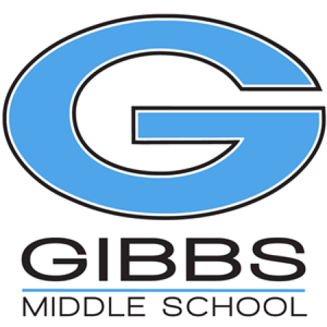

Dear Friends of Gibbs Middle School,

Gibbs Middle School Cheerleading Team requires cheerleaders to raise at least $100.00 in donation(s) each year to be placed in the Cheerleading Team general account. This account pays for uniform cost, and miscellaneous expenses accrued throughout the year.

To show our appreciation, a banner will be made and displayed with the names of all the businesses who have donated $100 or more to the Cheerleading Team by May 20th, 2019.

Gibbs Middle School is a public school and a government entity making your donation tax deductible.

If you have any questions, please feel free to contact Shanda Anderson at [shanda.anderson@knoxschools.org](mailto:shanda.anderson@knoxschools.org) or Caitin Long at [caitlin.long@knoxschools.org](mailto:caitlin.long@knoxschools.org).

Thank you for your generous donation and support.

Donation amount $________________

Made by ____________________________________

GMS Cheerleader___________________________________